# File permissions in Linux

## Project description

MANAGE AUTHORIZATION

## Check file and directory details

* USED the command PWD to see which directory we’re navigating in. In this case the /home/researcher2 file path. We change the directory to the **projects** folder. Once in the folder we use the **ls -l** command in order to list the contents in the folder.
* The contents shown below are documents for the **research_team** group.
* 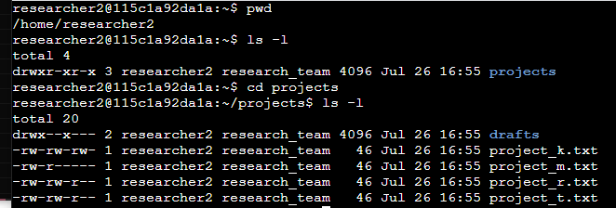

## 

## Describe the permissions string

* **drwxrwxrwx** is the default permissions that is assigned for Read, Write, and Execute permissions for User, Group, and Other in a Directory folder.
* D - directory
* Rwx - R - Read, W - Write, X - Execute
* 1st rwx - user,rwx - group, rwx - other
* Requires command chmod in order to modify permissions
* For example **project_m.txt,** the permissions read as **-rw-r----**
* **rw-** User has Read, Write - Permissions
* **-r-** Group has Read-Only Permissions
* **---** Other has no Read, Write, or Execute Permissions

## Change file permissions

* We check the files in the projects directory to see if any of the projects have write permissions for the owner type.
* For **project_k.txt** this is the only file that grants permissions to other users for write permissions
* As written for **project_k.txt**:
  + **-rw-rw-rw**
* We use the command **chmod o-w project_k.txt** chmod means change mode or change modification. The **o-w** alongside **chmod** means other user take away **(-w)** write permissions from **project_k.txt**

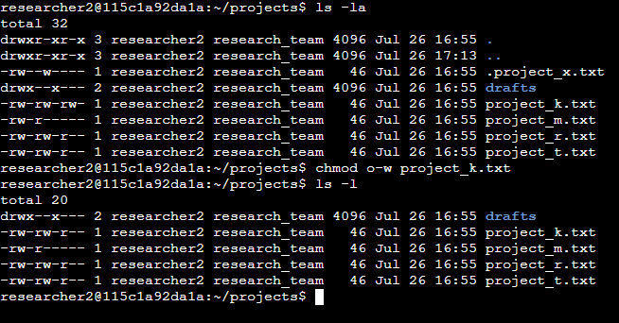

## Change file permissions on a hidden file

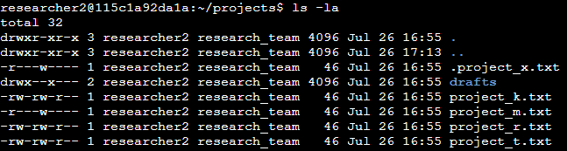

We use the command ls -la in order to list hidden files. We find a hidden file called .project_x.txt. The current file shows the permissions are written as -r---w---- . This file permission for the group is incorrect write permissions. For the hidden file **.project_x.txt**

We change the user permission on **.project_x.txt** so that the user and the group can have read-only permissions, but no write permissions to the file. We use the command **chmod u-w,g-w,g+r .project_x.txt** in order to make the necessary changes on user permissions.

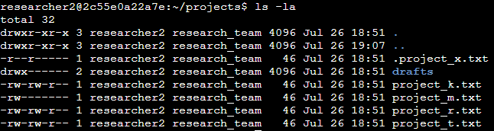

## 

## 

## 

## Change directory permissions

drwx --x --- drafts

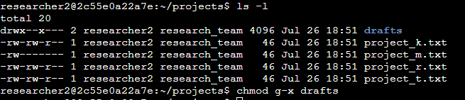

drwx --- --- drafts

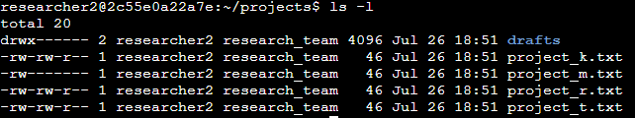

## Summary

[Add content here.]